Execution Procedure  
  
> First of all we have to open 2 cmd’s one in the my-app folder to run the react files and other one inside the web folder to run the backend node.js.  
> First run the backend so that is will be ready to take the inputs from the front end by specifying the port number in the login page with the help of axios.

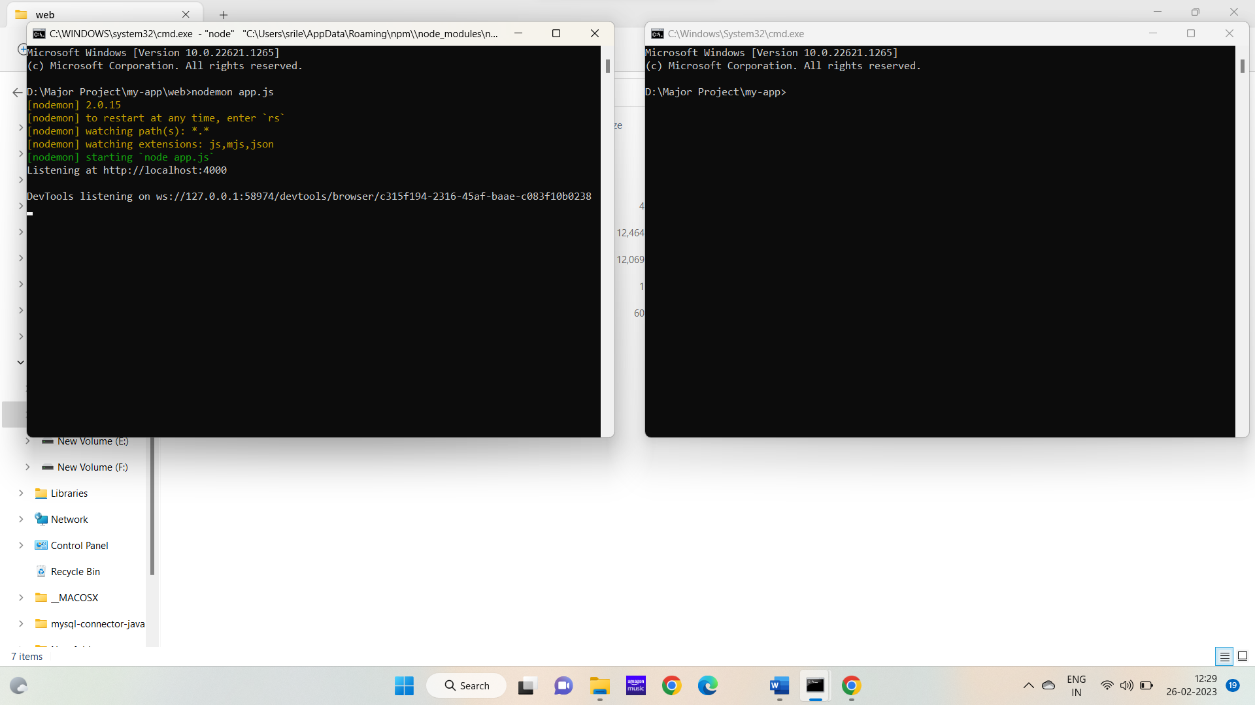  
  
> Next run the react app as npm start in another cmd.

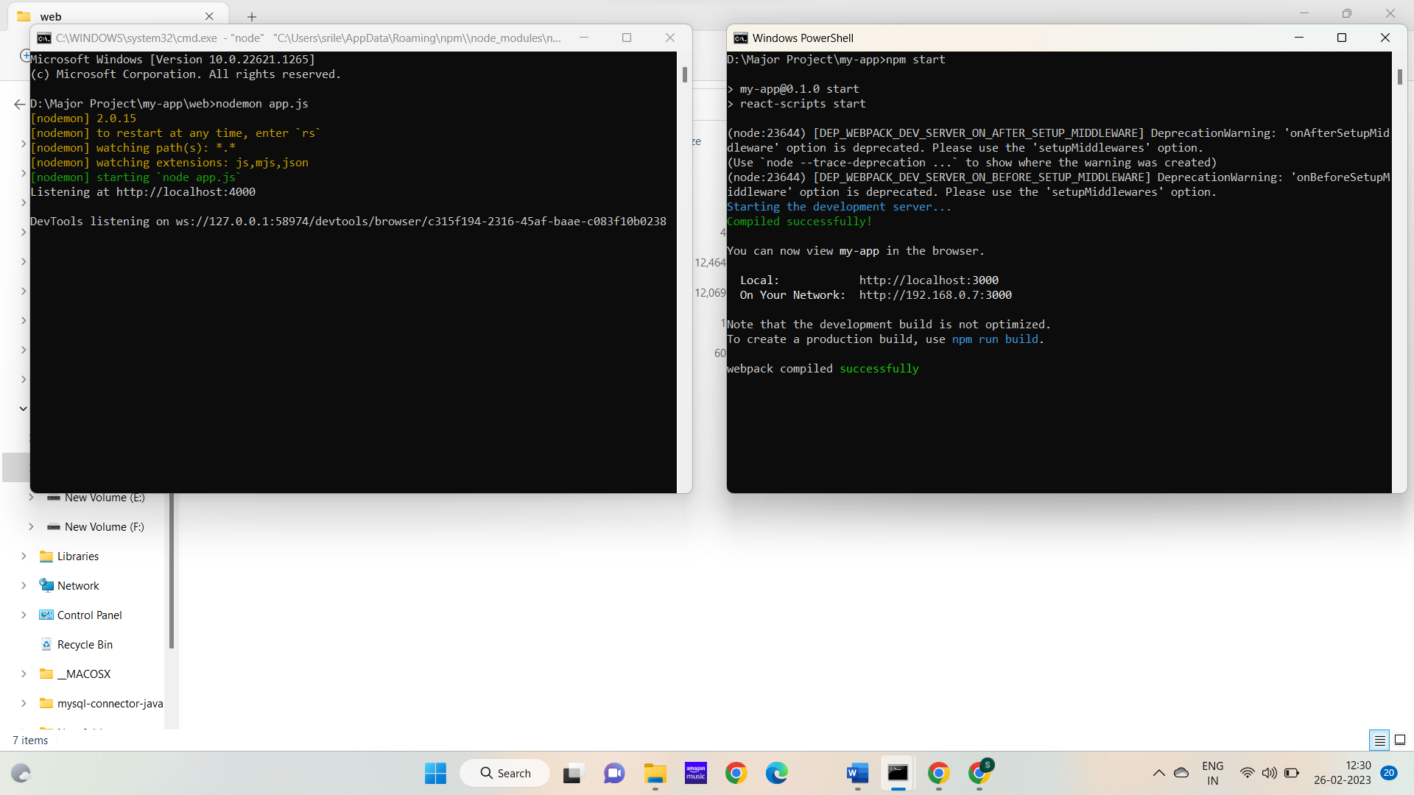  
  
> The web page gets opened automatically and we must enter all the details.

* If we click on enter without entering all the details:

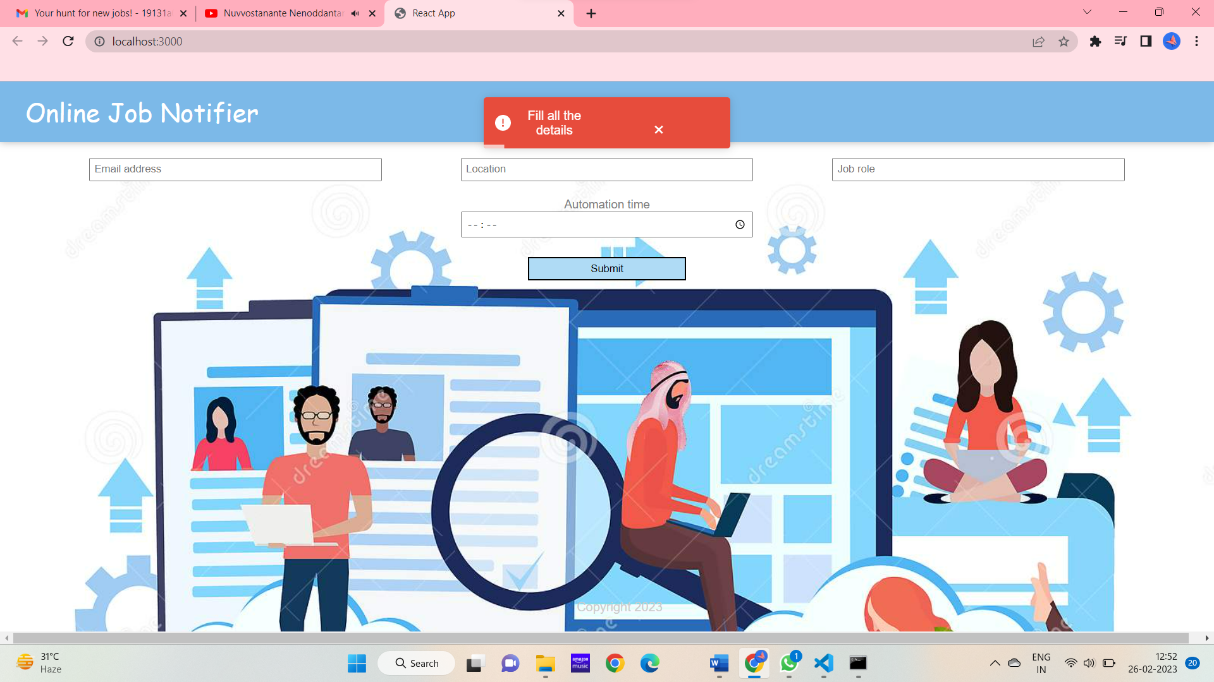

* Automation time is nothing but the period of time that we must receive mails. 00:00 means we must receive updated mails every 24 hours.  
  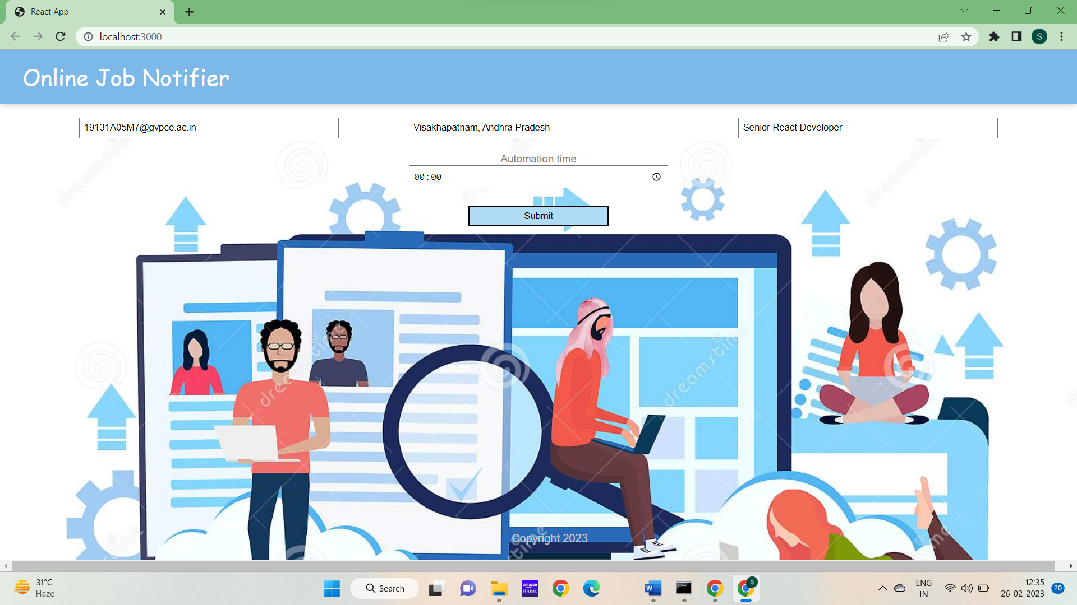  
    
  > After clicking on submit all the inputs are submitted and another page gets redirected.

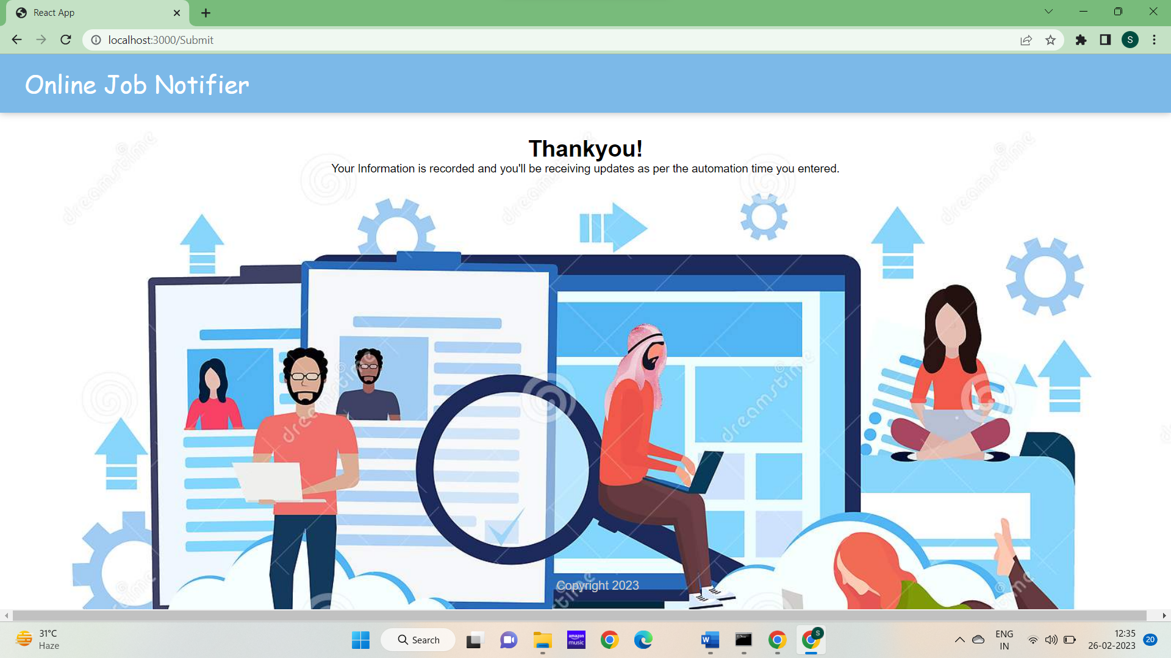

Now open the backened cmd and check in the cmd there will be the list of all jobs and above the url we can see all the inputs are printed that we’ve given in the frontend.  
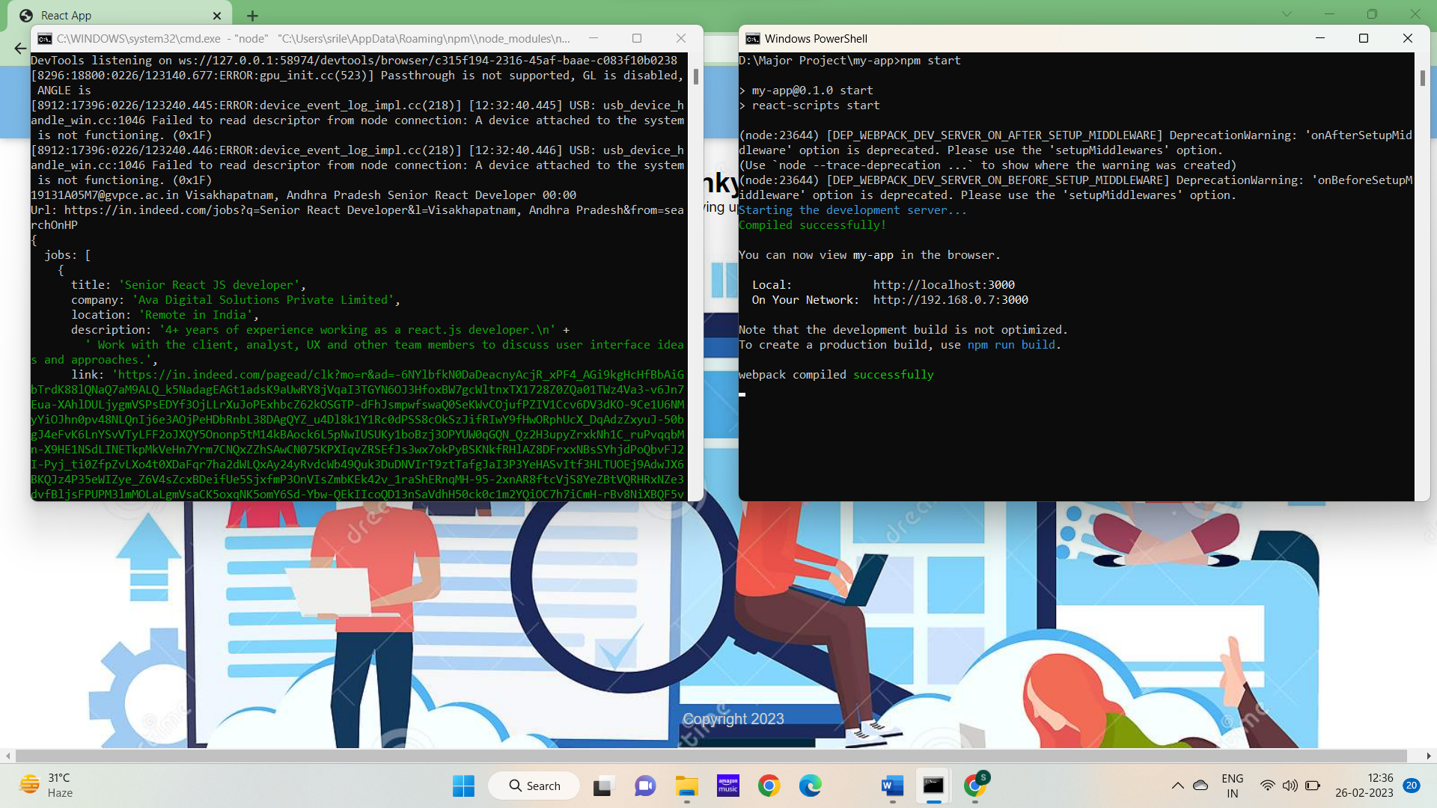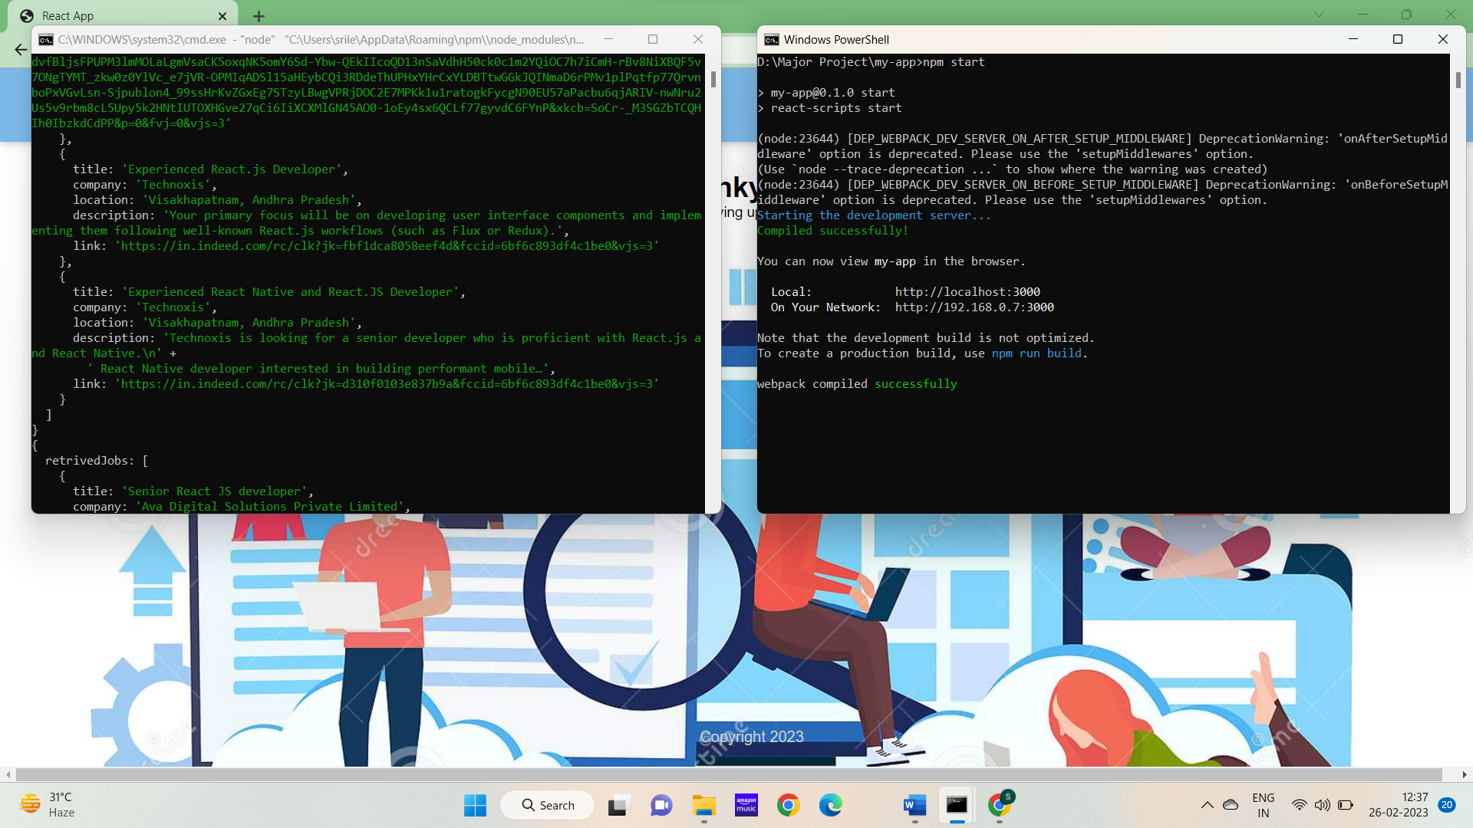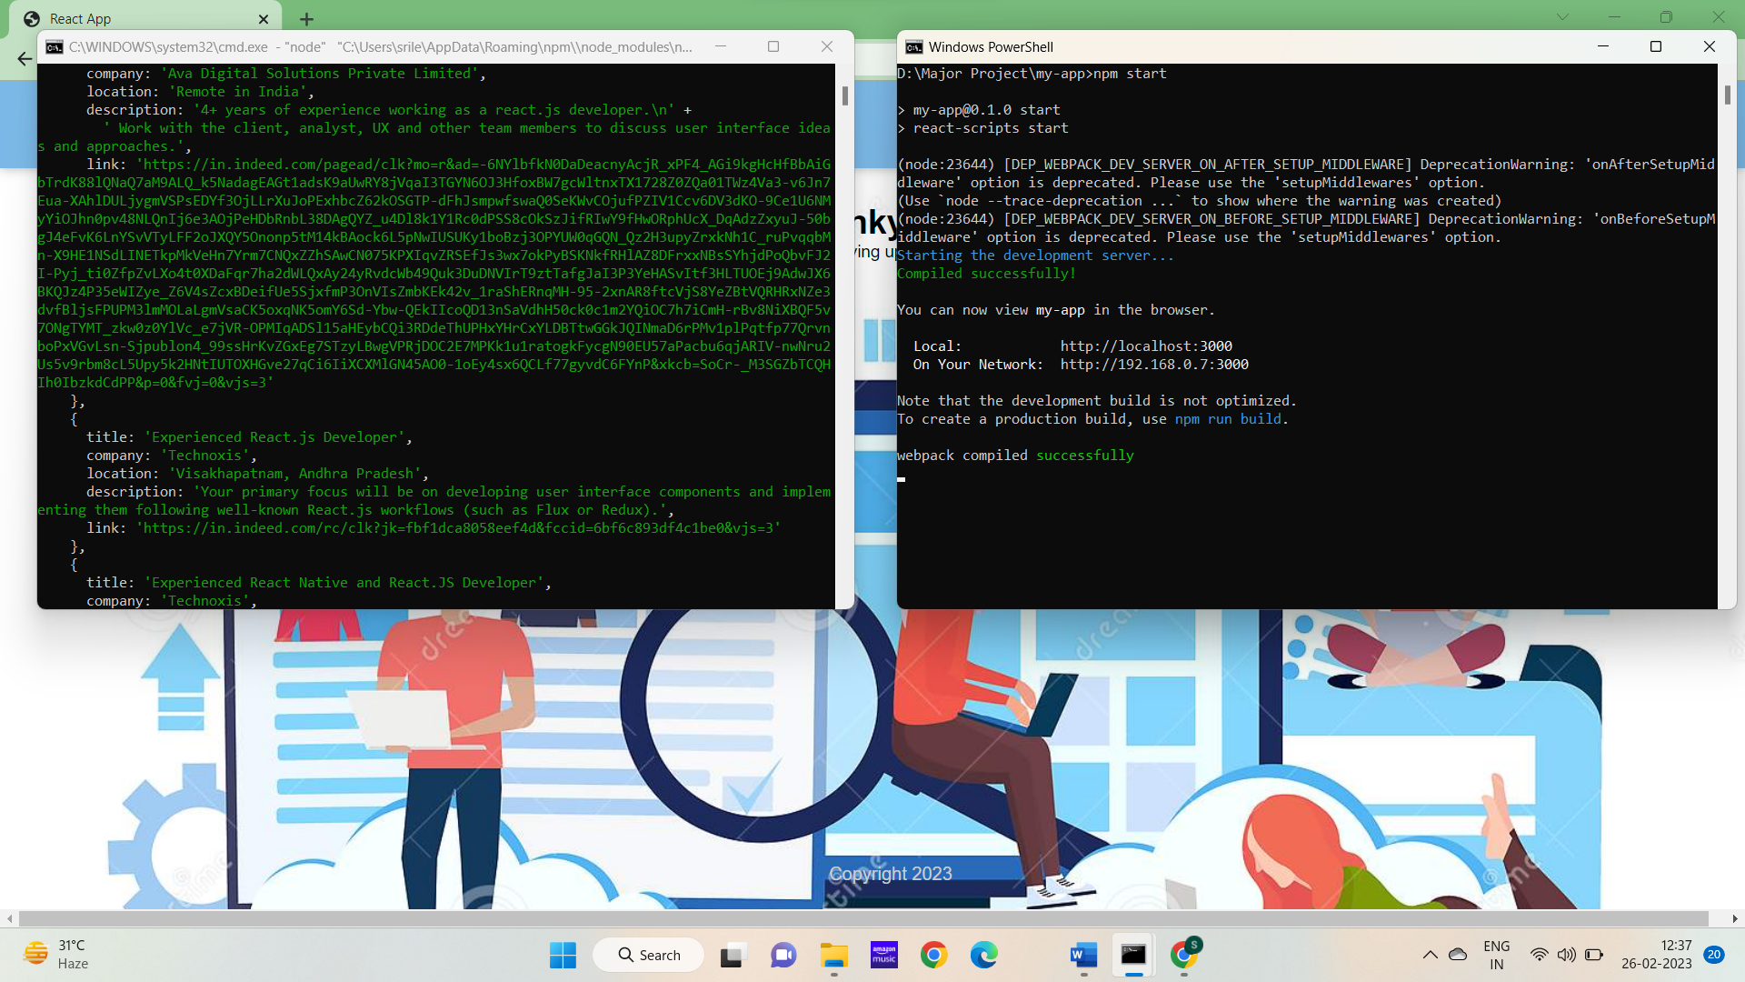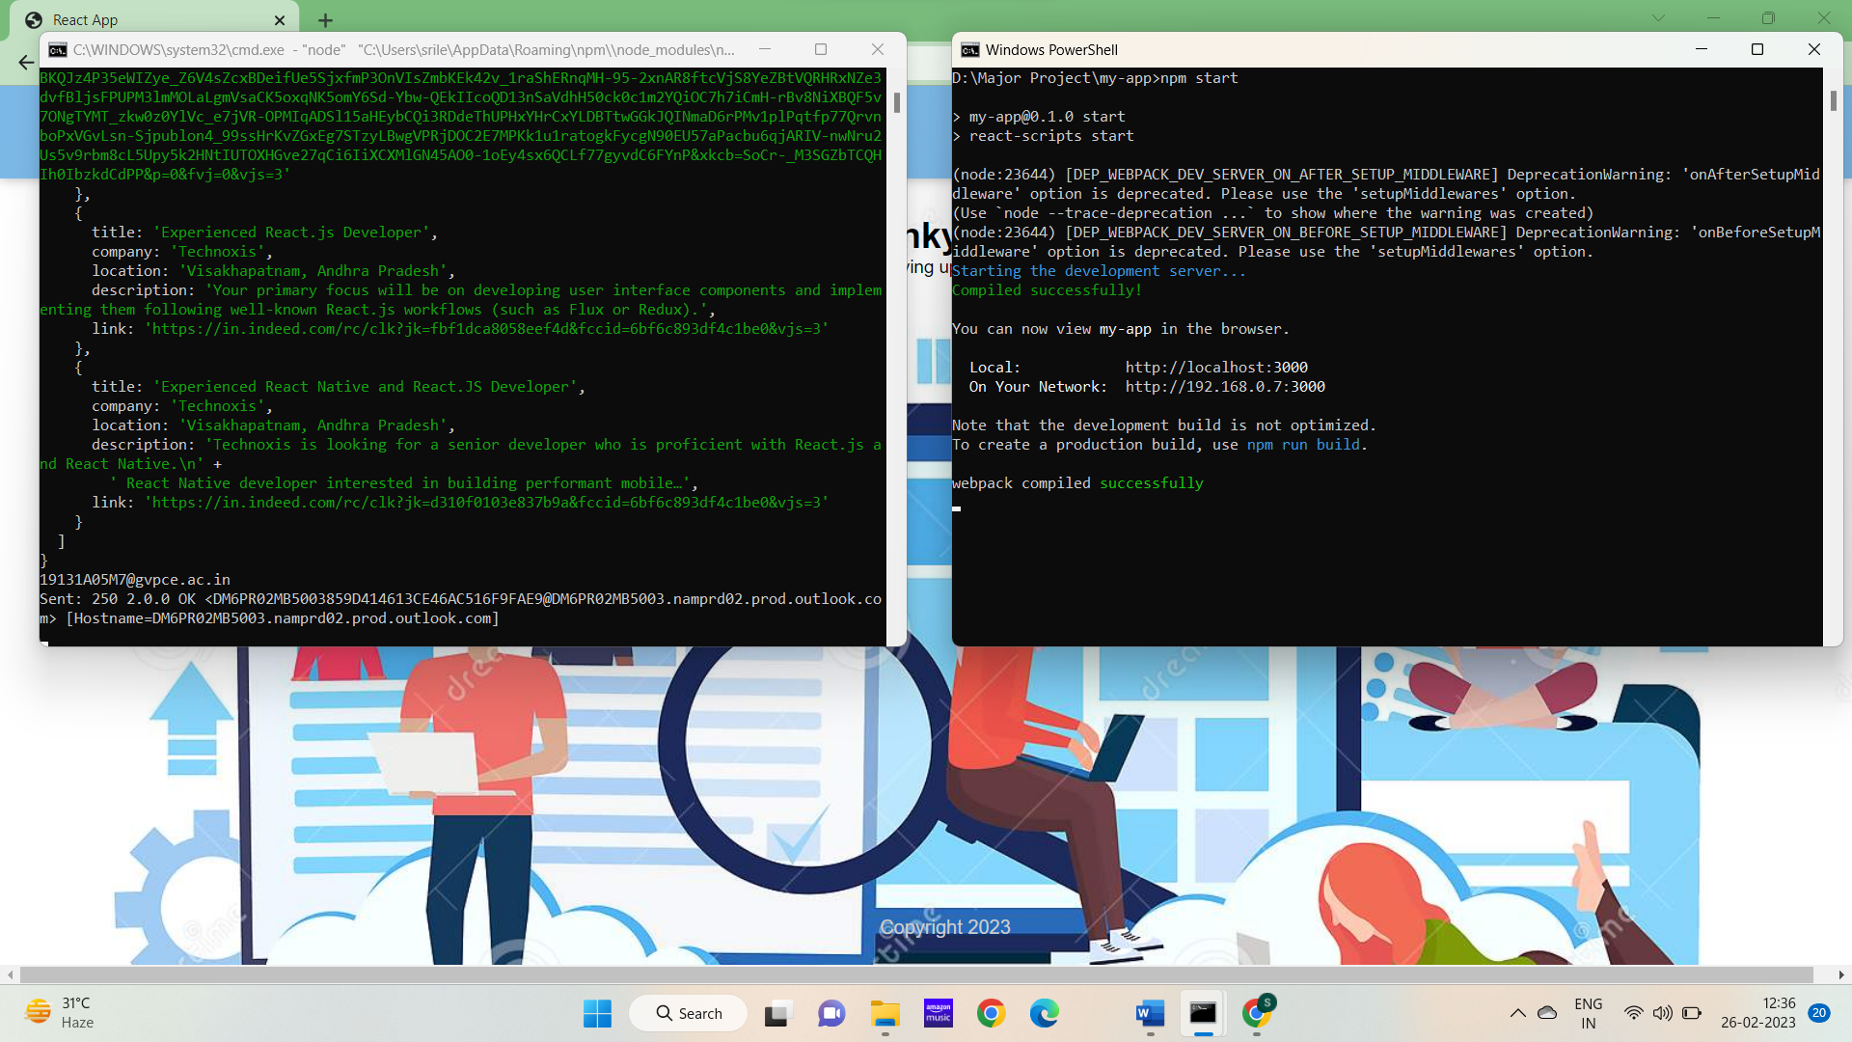  
  
> After sending the mail the cmd shows sent status then check your mail.

